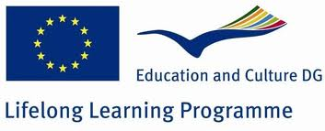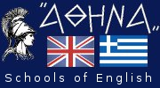

## Logo FROG

## 

The institution Centres of English Language Learning (Schools of English) “ATHENA” is happy to announce its participation in the second, consecutive European Programme **Grundtvig**. The main purpose of the programme is to raise public awareness of the need of a sustainable environmental education. It focuses both on tutors and learners who through creative and innovative indoor and outdoor activities are bound to improve their teaching and learning methods and abilities respectively. Teaching staff and learners should actively involve in several activities such as conferences, organising and participating in training sessions and local activities such as research on the topic, tours on foot with a view to criticizing and visiting eco parks, contacting organizations and authorities which deal with environmental issues. The most crucial ones will be recorded, photographed, monitored and this material will be used as an interactive material, tool which will be presented on the project web site.

It is every individual’s lifelong responsibility to keep the earth green and unspoilt for the next generations and having a good command of the English language is the only way to promote and transmit this message worldwide!!!!!!

**Aims of the project:**

* To foster awareness of the importance of the environment
* To stimulate creativity
* To promote the use of new technologies for adults and older learners
* To promote equal opportunities regardless of age, gender, disability or race
* To improve language skills

**Coordinator:**

Escola Oficial de Idiomas de Ferrol-Ferrol,Spain

**Partners:**

1. Centres of English Language Learning “ATHENA", Greece

2.Zakowo NET s.r.o, Czech Republic

3.Kelmes anglu kalbos klubas “ABC”, Lithuania

4.Quarter Mediation, Netherlands

5.Ozel Okul Oncesi Egitim Kurumlari Dernegi , Turkey

6. Universita delle LiberEta del FVG, Italy

**Contact info**

**First school:** Central square of Karditsa

**Second-Baby School:** Iezikihl 77

**Phone/Fax number:** (0030) 24410 28089, mobile (0030) 6977563888

**e-mail:** athenastroggili@gmail.com  
**URL:** [www.athenadinosenglishschools.gr](http://www.athenadinosenglishschools.gr/)